Technical Assessment: ERS

Author: Matthew W. Noble, DPhil [About the Author]

Date of Submission: 2018 January 08

# Preamble

This technical assessment was performed by Matthew W. Noble for the Pricing Analyst role at ERS. The deadline for submission was 07:00 on 2018/01/08. The Brief, What to submit, and Data Dictionary were provided by ERS to explain the task. In addition to this information, the data to be used was provided as a .csv file named:

ERS_Technical_Assessment_data.csv

and a sample .csv submission file was provided, named:

Sample_Submission.csv

All materials provided and used throughout are available in the directory:

…\CodingChallenges\ERS

# Brief

Evaluate the relative risk of a number of regions. Use the provided vehicle risk data with a selection of area related features attached to evaluate the relative risk of each region. You must assign a rating (1-99, low to high) for each region that is representative of its relative risk.

The dataset comprises of 32 columns, including 28 of area-related features that you may use to analyse relative area risk.

You may analyse the data any way you like. However, assessment will consider both the technical quality of your work and your ability to present the results. You can assume you will be presenting to an audience familiar with statistical methods and the insurance context (senior actuary or senior underwriter). You should be prepared to answer technical questions on the methods that you have elected to use.

Please annotate your code/analysis and ensure that your presentation includes the following:

1. Brief commentary on rationale for the method(s) employed[1]
2. Analysis of strengths and weaknesses of your approach
3. Brief description of any evaluation metric(s) that you used

# What to submit:

Candidates must submit three exhibits:

1. **Short presentation**, (15 min) which you will present as part of the assessment. You should be prepared to explain and defend your work during a 15 min Q&A session following the presentation. Please provide as either PowerPoint/pdf/RMarkDown/html etc.
2. **CSV file with each of the regions and resulting 1-99 scores**.Please give the regions a rating between 1 and 99 related to their predicted risk level (with 99 being the highest risk regions). We have supplied a template for the submission exhibit.[2]
3. **Supporting information**, ideally as a single zip file. Please provide sufficient code, model files and/or documentation of your analysis in a legible format (html, pynb, R, excel etc.) so that your work could be repeated by an appropriately trained analyst. Please ensure that any accompanying visualisations and annotations render correctly and can be viewed after emailing.

# Data Dictionary

## Observation details

|  |  |
| --- | --- |
| Region | An identifier for each region |
| Frequency | Rate of Claims within a given region (Number of Claims/Exposure) |
| Exposure (EVY) | Measure of exposure within the Region in earned vehicle years; Measure of the experience within the region (how much time*number of vehicles the data has been recorded for) |
| Non_Area_Related_Veh_Risk | Measure of Non-Area Related risk for the given region; a measure of risk that is not related to the Area (based on other factors such as types of car, age of drivers etc.) |

## Area-related features

|  |  |
| --- | --- |
| Location_Type | Type of Location |
| Local_Authority_Code | Code representing different Local Authorities |
| Density | Population Density |
| Traffic_Flow | Average Traffic Flow within the region |
| Distance_Travelled | Average Distance travelled within the Region |
| Averaged_Density | Population Density (Smoothed) |
| Distance_Travelled_2 | Average Distance travelled within the Region (Smoothed) |
| Local_Crimes | Number of Local Crimes |
| Young | Proportion of the population that is 'Young' |
| Mid | Proportion of the population that is 'Middle Aged' |
| Old | Proportion of the population that is 'Old' |
| Points_Per_License_Avg | Average points per License (Smoothed) |
| Avg_Drivers | Average number of Drivers within the Region (Smoothed) |
| Avg_Pts | Average Number of Penalty Points (Smoothed) |
| Points_Per_License | Average points per License |
| Drivers | Average number of Drivers within the Region |
| Pts | Average Number of Penalty Points |
| Local_Schools | Average number of  Local Schools |
| Local_CMCs | Average number of  Claims Management Companies |
| Nearest_CMC | Average distance to the nearest Claims Management Company |
| Nearest_School | Average distance to the nearest School |
| Nearest_Incidents | Average distance to the nearest Incident |
| Nearest_Crimes | Average distance to the nearest Crime |
| Local_Incidents_Sev1 | Number of High Severity Incidents |
| Local_Incidents_Sev2 | Number of Medium Severity Incidents |
| Local_Incidents_Sev3 | Number of Low Severity Incidents |
| Incident_Severity_Ratio1 | Ratio of the number of High to Low Severity Incidents |
| Incident_Severity_Ratio2 | Ratio of the number of High to Low Severity Incidents (2) |

# Data Analysis

Printing the .head(10) of each of the columns:

|  |  |  |
| --- | --- | --- |
| Region  1 0.073234  2 0.059753  3 0.000000  4 0.000000  5 0.037753  6 0.074187  7 0.000000  8 0.000000  9 0.000000  10 0.000000  Name: Frequency, dtype: float64 | Region  1 13.654795  2 33.471233  3 27.657534  4 4.397260  5 26.487671  6 13.479452  7 11.802740  8 9.660274  9 23.449315  10 32.542466  Name: Exposure (EVY), dtype: float64 | Region  1 0.051595  2 0.030824  3 0.035585  4 0.023894  5 0.029252  6 0.040134  7 0.040027  8 0.039755  9 0.027125  10 0.032035  Name: Non_Area_Related_Veh_Risk, dtype: float64 |
| Region  1 Large urban area  2 Large urban area  3 Large urban area  4 Large urban area  5 Large urban area  6 Large urban area  7 Large urban area  8 Large urban area  9 Large urban area  10 Accessible small town  Name: Location_Type, dtype: object | Region  1 338  2 338  3 338  4 338  5 338  6 338  7 338  8 338  9 338  10 339  Name: Local_Authority_Code, dtype: int64 | Region  1 11.870000  2 11.870000  3 11.870000  4 11.870000  5 11.870000  6 11.870000  7 11.870000  8 11.870000  9 11.494291  10 0.454134  Name: Density, dtype: float64 |
| Region  1 1314.000000  2 1314.000000  3 1314.000000  4 1314.000000  5 1314.000000  6 1314.000000  7 1314.000000  8 1314.000000  9 1362.861818  10 2798.659218  Name: Traffic_Flow, dtype: float64 | Region  1 4.715810  2 4.715810  3 4.715810  4 4.715810  5 4.715810  6 4.715810  7 4.715810  8 4.715810  9 4.852145  10 8.858346  Name: Distance_Travelled, dtype: float64 | Region  1 11.639188  2 11.639188  3 11.639188  4 11.725474  5 11.725474  6 11.725474  7 11.725474  8 11.725474  9 10.223148  10 10.223148  Name: Averaged_Density, dtype: float64 |
| Region  1 4.735272  2 4.735272  3 4.735272  4 4.727951  5 4.727951  6 4.727951  7 4.727951  8 4.727951  9 4.888633  10 5.614635  Name: Distance_Travelled_2, dtype: float64 | Region  1 NaN  2 NaN  3 NaN  4 NaN  5 NaN  6 NaN  7 NaN  8 NaN  9 NaN  10 NaN  Name: Local_Crimes, dtype: float64 | Region  1 0.297859  2 0.297859  3 0.297859  4 0.297859  5 0.297859  6 0.297859  7 0.297859  8 0.297859  9 0.293943  10 0.178874  Name: Young, dtype: float64 |
| Region  1 0.596964  2 0.596964  3 0.596964  4 0.596964  5 0.596964  6 0.596964  7 0.596964  8 0.596964  9 0.600482  10 0.703831  Name: Mid, dtype: float64 | Region  1 0.105177  2 0.105177  3 0.105177  4 0.105177  5 0.105177  6 0.105177  7 0.105177  8 0.105177  9 0.105576  10 0.117295  Name: Old, dtype: float64 | Region  1 0.385406  2 0.385406  3 0.385406  4 0.387316  5 0.387316  6 0.387316  7 0.387316  8 0.387316  9 0.385936  10 0.385936  Name: Points_Per_License_Avg, dtype: float64 |
| Region  1 4.503306e+09  2 4.503306e+09  3 4.503306e+09  4 4.352629e+09  5 4.352629e+09  6 4.352629e+09  7 4.352629e+09  8 4.352629e+09  9 4.063142e+09  10 4.063142e+09  Name: Avg_Drivers, dtype: float64 | Region  1 1.735603e+09  2 1.735603e+09  3 1.735603e+09  4 1.685844e+09  5 1.685844e+09  6 1.685844e+09  7 1.685844e+09  8 1.685844e+09  9 1.568113e+09  10 1.568113e+09  Name: Avg_Pts, dtype: float64 | Region  1 0.381379  2 0.381379  3 0.381379  4 0.455668  5 0.455668  6 0.455668  7 0.455668  8 0.455668  9 0.430636  10 0.430636  Name: Points_Per_License, dtype: float64 |
| Region  1 13619  2 13619  3 13619  4 10613  5 10613  6 10613  7 10613  8 10613  9 18057  10 18057  Name: Drivers, dtype: int64 | Region  1 5194  2 5194  3 5194  4 4836  5 4836  6 4836  7 4836  8 4836  9 7776  10 7776  Name: Pts, dtype: int64 | Region  1 31.229665  2 30.393443  3 20.801802  4 24.772059  5 28.916279  6 24.385965  7 18.056338  8 20.010638  9 8.134545  10 4.770950  Name: Local_Schools, dtype: float64 |
| Region  1 0.0  2 0.0  3 0.0  4 0.0  5 0.0  6 0.0  7 0.0  8 0.0  9 0.0  10 0.0  Name: Local_CMCs, dtype: float64 | Region  1 92510.53574  2 91301.51103  3 89885.89469  4 93174.01919  5 92332.31336  6 91829.33639  7 92414.77910  8 92663.55376  9 89711.34458  10 84468.03051  Name: Nearest_CMC, dtype: float64 | Region  1 265.038480  2 329.699334  3 528.182239  4 506.163139  5 372.889342  6 410.321541  7 341.666668  8 466.276593  9 646.086135  10 631.437361  Name: Nearest_School, dtype: float64 |
| Region  1 1095.857770  2 1908.613982  3 3014.955096  4 1896.529820  5 1040.038110  6 2611.003055  7 2223.648806  8 2340.519333  9 4516.650995  10 5152.652589  Name: Nearest_Incidents, dtype: float64 | Region  1 NaN  2 NaN  3 NaN  4 NaN  5 NaN  6 NaN  7 NaN  8 NaN  9 NaN  10 NaN  Name: Nearest_Crimes, dtype: float64 | Region  1 9.076555  2 9.118852  3 10.797297  4 9.044118  5 9.018605  6 9.000000  7 9.000000  8 9.021277  9 10.963636  10 11.000000  Name: Local_Incidents_Sev1, dtype: float64 |
| Region  1 105.976077  2 108.057377  3 111.711712  4 103.080882  5 105.232558  6 105.315790  7 101.577465  8 102.000000  9 107.109091  10 120.474860  Name: Local_Incidents_Sev2, dtype: float64 | Region  1 357.832536  2 360.200820  3 354.977477  4 350.492647  5 356.511628  6 352.771930  7 340.795775  8 343.638298  9 328.538182  10 348.217877  Name: Local_Incidents_Sev3, dtype: float64 | Region  1 0.019206  2 0.019101  3 0.022613  4 0.019554  5 0.019160  6 0.019270  7 0.019941  8 0.019844  9 0.024570  10 0.022942  Name: Incident_Severity_Ratio1, dtype: float64 |
| Region  1 0.243320  2 0.245450  3 0.256575  4 0.242389  5 0.242697  6 0.244741  7 0.244990  8 0.244206  9 0.264432  10 0.274152  Name: Incident_Severity_Ratio2, dtype: float64 |  |  |

Generating the correlation matrix:

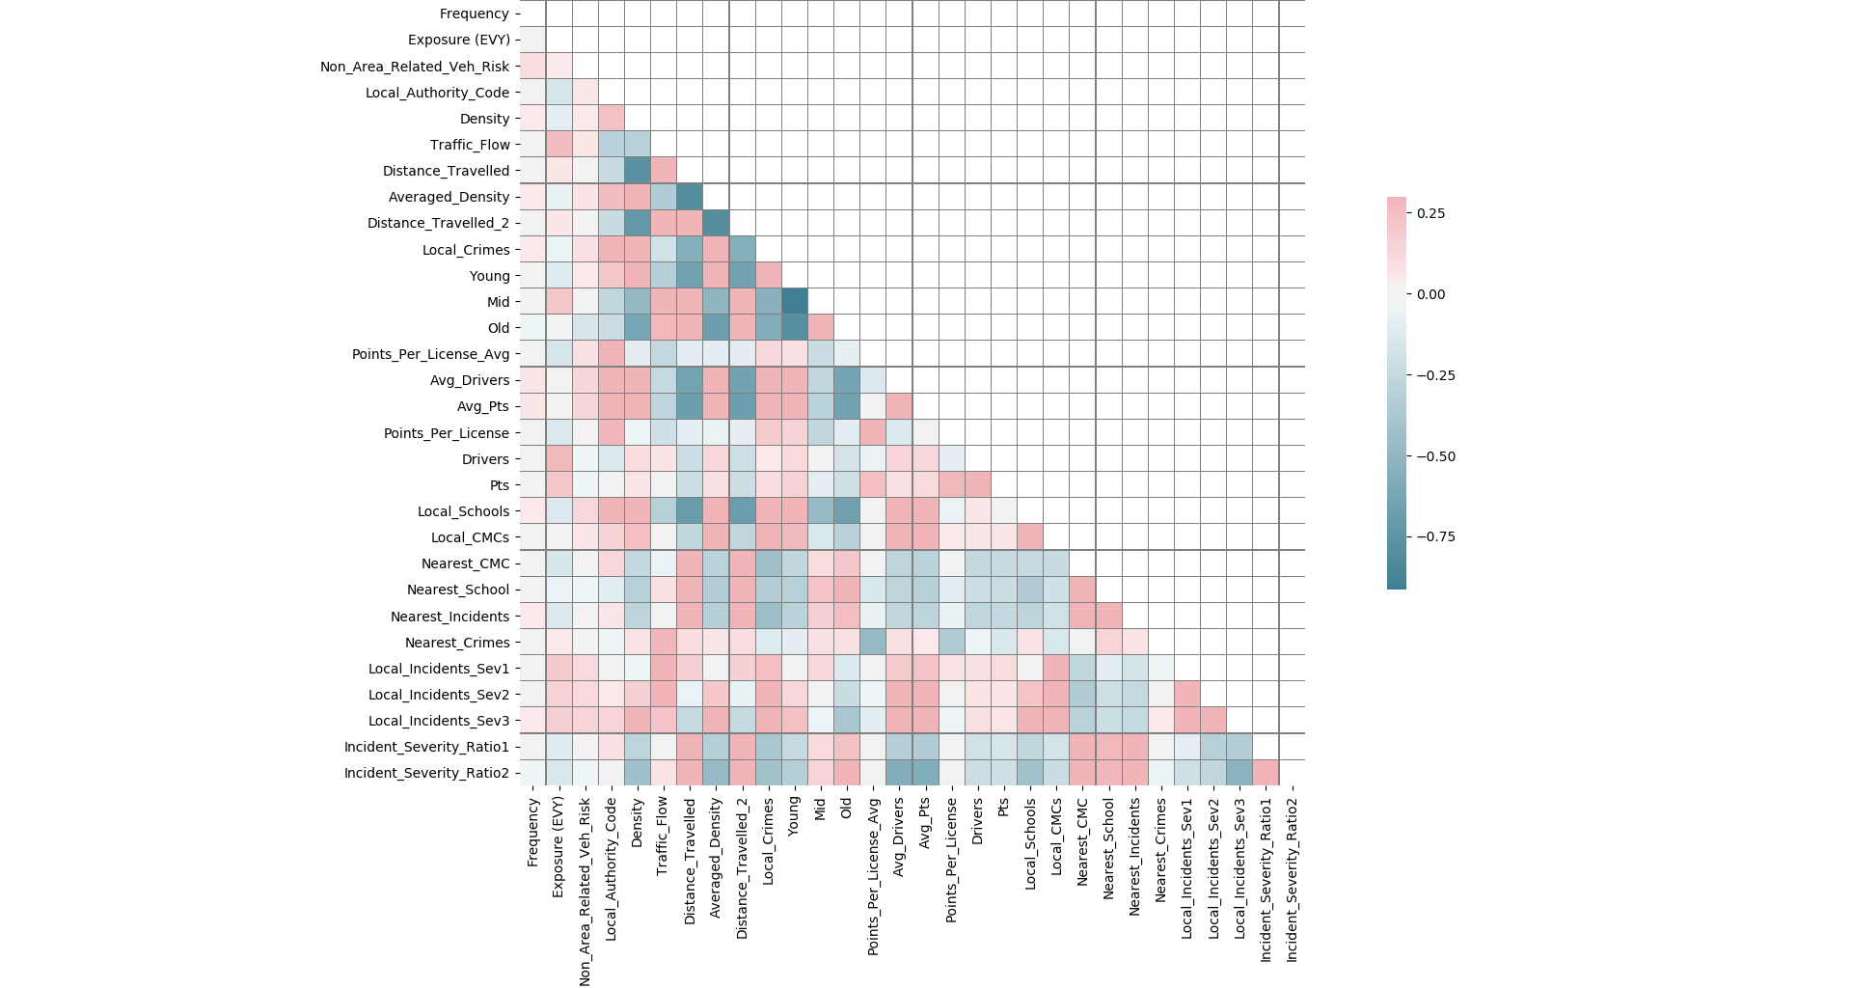

**Figure 1**: Correlation matrix for all of the numerical fields.

Printing the .info() of the DataFrame:

<class 'pandas.core.frame.DataFrame'>

Int64Index: 8995 entries, 1 to 8995

Data columns (total 31 columns):

Frequency 8995 non-null float64

Exposure (EVY) 8995 non-null float64

Non_Area_Related_Veh_Risk 8995 non-null float64

Location_Type 8995 non-null object

Local_Authority_Code 8995 non-null int64

Density 8995 non-null float64

Traffic_Flow 8995 non-null float64

Distance_Travelled 8995 non-null float64

Averaged_Density 8995 non-null float64

Distance_Travelled_2 8995 non-null float64

Local_Crimes 8076 non-null float64

Young 8995 non-null float64

Mid 8995 non-null float64

Old 8995 non-null float64

Points_Per_License_Avg 8995 non-null float64

Avg_Drivers 8995 non-null float64

Avg_Pts 8995 non-null float64

Points_Per_License 8995 non-null float64

Drivers 8995 non-null int64

Pts 8995 non-null int64

Local_Schools 8995 non-null float64

Local_CMCs 8995 non-null float64

Nearest_CMC 8995 non-null float64

Nearest_School 8995 non-null float64

Nearest_Incidents 8995 non-null float64

Nearest_Crimes 8076 non-null float64

Local_Incidents_Sev1 8995 non-null float64

Local_Incidents_Sev2 8995 non-null float64

Local_Incidents_Sev3 8995 non-null float64

Incident_Severity_Ratio1 8994 non-null float64

Incident_Severity_Ratio2 8994 non-null float64

dtypes: float64(27), int64(3), object(1)

memory usage: 2.2+ MB

None

Printing the .describe() of the columns:

|  |  |  |
| --- | --- | --- |
| count 8995.000000  mean 0.028664  std 0.050857  min 0.000000  25% 0.000000  50% 0.021409  75% 0.042160  max 3.041667  Name: Frequency, dtype: float64 | count 8995.000000  mean 53.418893  std 46.063739  min 0.024658  25% 22.547945  50% 43.430137  75% 72.052055  max 717.043835  Name: Exposure (EVY), dtype: float64 | count 8995.000000  mean 0.028617  std 0.006235  min 0.004053  25% 0.024827  50% 0.028214  75% 0.031771  max 0.108312  Name: Non_Area_Related_Veh_Risk, dtype: float64 |
| count 8995  unique 18  top Urban city and town  freq 3233  Name: Location_Type, dtype: object | count 8995.000000  mean 203.059255  std 116.543219  min 1.000000  25% 87.000000  50% 234.000000  75% 298.000000  max 380.000000  Name: Local_Authority_Code, dtype: float64 | count 8995.000000  mean 20.951530  std 27.788004  min 0.090000  25% 2.300000  50% 10.900000  75% 30.400000  max 222.500000  Name: Density, dtype: float64 |
| count 8995.000000  mean 4520.276012  std 4082.386467  min 130.328767  25% 1427.000000  50% 2640.093023  75% 7023.000000  max 15001.000000  Name: Traffic_Flow, dtype: float64 | count 8995.000000  mean 5.934158  std 2.117191  min 0.760321  25% 4.238439  50% 5.930679  75% 7.635787  max 11.291168  Name: Distance_Travelled, dtype: float64 | count 8995.000000  mean 20.695282  std 23.434869  min 0.090000  25% 2.770000  50% 13.415023  75% 30.420084  max 125.985899  Name: Averaged_Density, dtype: float64 |
| count 8995.000000  mean 5.828959  std 2.071059  min 0.791770  25% 4.162229  50% 5.763227  75% 7.407108  max 11.291168  Name: Distance_Travelled_2, dtype: float64 | count 8076.000000  mean 783.055966  std 742.687650  min 0.666667  25% 212.251489  50% 566.009427  75% 1118.286875  max 4435.114035  Name: Local_Crimes, dtype: float64 | count 8995.000000  mean 0.219562  std 0.051975  min 0.140163  25% 0.179334  50% 0.203184  75% 0.250932  max 0.401254  Name: Young, dtype: float64 |
| count 8995.000000  mean 0.680077  std 0.037085  min 0.545403  25% 0.665105  50% 0.688589  75% 0.706099  max 0.754181  Name: Mid, dtype: float64 | count 8995.000000  mean 0.129887  std 0.029027  min 0.049409  25% 0.111566  50% 0.129427  75% 0.149674  max 0.235469  Name: Old, dtype: float64 | count 8995.000000  mean 0.304938  std 0.064245  min 0.085989  25% 0.267553  50% 0.297476  75% 0.332714  max 0.571693  Name: Points_Per_License_Avg, dtype: float64 |
| count 8.995000e+03  mean 1.692946e+10  std 1.984901e+10  min 5.375230e+06  25% 4.873011e+09  50% 1.047710e+10  75% 1.907769e+10  max 8.337202e+10  Name: Avg_Drivers, dtype: float64 | count 8.995000e+03  mean 5.006738e+09  std 5.352610e+09  min 9.350906e+05  25% 1.387760e+09  50% 3.209109e+09  75% 6.539716e+09  max 2.201732e+10  Name: Avg_Pts, dtype: float64 | count 8995.000000  mean NaN  std NaN  min 0.000000  25% 0.257017  50% 0.297646  75% 0.346812  max Inf  Name: Points_Per_License, dtype: float64 |
| count 8995.000000  mean 18100.406782  std 10392.019105  min 0.000000  25% 10970.000000  50% 17186.000000  75% 23779.000000  max 83195.000000  Name: Drivers, dtype: float64 | count 8995.000000  mean 5479.610450  std 3319.290799  min 0.000000  25% 3188.000000  50% 5054.000000  75% 7106.000000  max 25351.000000  Name: Pts, dtype: float64 | count 8995.000000  mean 19.524790  std 24.797306  min 0.000000  25% 3.991331  50% 11.541667  75% 25.011430  max 149.000000  Name: Local_Schools, dtype: float64 |
| count 8995.000000  mean 20.324137  std 29.858313  min 0.000000  25% 2.594828  50% 10.382353  75% 26.583341  max 208.548837  Name: Local_CMCs, dtype: float64 | count 8995.000000  mean 11202.220560  std 24657.107516  min 64.740482  25% 1534.105676  50% 3664.657559  75% 10464.892175  max 441613.290100  Name: Nearest_CMC, dtype: float64 | count 8995.000000  mean 837.332549  std 972.181168  min 0.000000  25% 392.948464  50% 553.347347  75% 938.226576  max 46747.374840  Name: Nearest_School, dtype: float64 |
| count 8995.000000  mean 4442.679273  std 7557.616124  min 255.792433  25% 1538.527405  50% 2441.146737  75% 4774.950189  max 239210.402700  Name: Nearest_Incidents, dtype: float64 | count 8076.000000  mean 15940.251645  std 22240.829822  min 666.881605  25% 3439.899580  50% 7337.108007  75% 18914.223595  max 267240.086400  Name: Nearest_Crimes, dtype: float64 | count 8995.000000  mean 22.070543  std 14.543237  min 0.000000  25% 11.033231  50% 19.452128  75% 29.780088  max 94.231250  Name: Local_Incidents_Sev1, dtype: float64 |
| count 8995.000000  mean 306.645092  std 214.542391  min 0.000000  25% 148.559063  50% 265.359060  75% 426.077506  max 1494.967391  Name: Local_Incidents_Sev2, dtype: float64 | count 8995.000000  mean 2510.883463  std 2286.091082  min 0.000000  25% 963.833442  50% 1979.379310  75% 3196.966347  max 19024.195650  Name: Local_Incidents_Sev3, dtype: float64 | count 8994.000000  mean 0.011575  std 0.012880  min 0.000000  25% 0.005861  50% 0.009025  75% 0.013061  max 0.538760  Name: Incident_Severity_Ratio1, dtype: float64 |
| count 8994.000000  mean 0.138577  std 0.051668  min 0.000000  25% 0.109229  50% 0.134313  75% 0.162543  max 0.709302  Name: Incident_Severity_Ratio2, dtype: float64 |  |  |

The Location_Type column was a category column, looking at the unique counts of the categories via a .crosstab() implementation:

col_0 count

Location_Type

Accessible rural area 129

Accessible small town 81

Large urban area 297

Other urban area 224

Remote rural area 57

Remote small town 24

Rural hamlet and isolated dwellings 357

Rural hamlet and isolated dwellings in a sparse setting 106

Rural town and fringe 799

Rural town and fringe in a sparse setting 77

Rural village 551

Rural village in a sparse setting 73

Urban city and town 3233

Urban city and town in a sparse setting 26

Urban major conurbation 2612

Urban minor conurbation 239

Very remote rural area 95

Very remote small town 15

## Understanding and Inspecting the Data

### Observation Details

The **Frequency** field is the: *measure of the Rate of Claims within a given region (Number of Claims/Exposure)*. This will probably be important. The higher this rate, the more likely a region is to make a claim.

Possible errors: There is a frequency of 3.041667 in Region 5139. This is the only point above 1.0 and since this is a rate, I believe this to be incorrect. I have changed this to the 2nd highest value of: 0.910224. This was done in Excel as it was faster.

The **Exposure (EVY)** field is the: *Measure of exposure within the Region in earned vehicle years; Measure of the experience within the region (how much time*number of vehicles the data has been recorded for)*. This is probably not important as I will include the **Frequency** field and the **Exposure** and **Frequency** fields are not independent.

The **Non_Area_Related_Veh_Risk** field is the: *Measure of Non-Area Related risk for the given region ; a measure of risk that is not related to the Area (based on other factors such as types of car, age of drivers etc.)*. This will probably be important. The higher this rate, the more likely a region is to make a claim. This is independent of the area-related features, which is good.

## Area-related features

The **Location_Type** field is the: *Type of Location*. This is probably not important. It will no doubt be linked to other things in the area-related features, but is itself not important.

The **Local_Authority_Code** field is the: *Code representing different Local Authorities*. This is probably not important. It will no doubt be linked to other things in the area-related features, but is itself not important.

The **Density** is the: *Population Density*. This is probably not important. The **Averaged_Density** field will be used instead as it is smoothed.

The **Traffic_Flow** field is the: *Average Traffic Flow within the region*. This will probably be important. The higher the traffic flow within a region, the more likely an accident is to happen.

The **Distance_Travelled** field is the: *Average Distance travelled within the Region*. This is probably not important. The **Distance_Travelled_2** field will be used instead as it is smoothed.

The **Averaged_Density** field is the: *Population Density (Smoothed)*. This will probably be important. This will allow metrics to be calculated per population.

The **Distance_Travelled_2** field is the: *Average Distance travelled within the Region (Smoothed)*. This will probably be important. My initial thoughts were that the longer the distance travelled, the more time spent inside a vehicle, and therefore the more likely to have an incident. Upon reflection, the more time spent inside of a vehicle, the more likely they are going to transition to a motorway or be on a long journey, and hence not be continuously stopping and starting. Therefore the larger the distance, the less likely of an incident.

The **Local_Crimes** field is the: *Number of Local Crimes*. This is probably not important. It will no doubt be linked to other things in the area-related features, but is itself not important. This investigation is looking at vehicle risk, therefore unless there is a way to separate out the vehicle crimes from all crimes (which I do not believe there is), this field is meaningless. Your risk of being burgled or mugged and your risk of being rear-ended are not related.

The **Young** field is the: *Proportion of the population that is 'Young'*. This will probably be important. Young drivers who have just passed their test do not yet have road experience and are more likely to be impulsive. Increased risk relative to the **Mid** field.

The **Mid** field is the: *Proportion of the population that is 'Middle Aged'*. This will probably be important. Mid drivers have road experience and are less likely to be impulsive. Decreased risk relative to both the **Young** and **Old** fields.

The **Old** field is the: *Proportion of the population that is 'Old'*. This will probably be important. Old drivers have the most road experience but have become complacent in their old age and are becoming sensory impaired. Increased risk relative to the **Mid** field.

The **Points_Per_License_Avg** field is the: *Average points per License (Smoothed)*. This will probably be important. This is a measure of whether the drivers in that region obey the laws of the road or not.

The **Avg_Drivers** field is the: *Average number of Drivers within the Region (Smoothed)*. This will probably be important. More drivers in a region means more likelihood of an incident occurring. This will also allow metrics to be calculated per driver.

The **Avg_Pts** field is the: *Average Number of Penalty Points (Smoothed)*. This is probably not important. This is a smoothed value, which makes it better than the **Pts** field, but it is still an absolute. The **Points_Per_License_Avg** will be used instead.

The **Points_Per_License** field is the: *Average points per License*. This is probably not important. The **Points_Per_License_Avg** field will be used instead as it is smoothed.

Possible errors: Two values, for regions 5083 and 2330 were labelled as having Inf values. This is of course impossible. I believe this is linked to the **Drivers** field for the two regions being 0. If this is the average points per licence and a “licence” is defined as a “driver” then dividing by 0 would explode this to Inf. To correct the two entries, the data was filtered by the **Location_Type** column such that only the Urban Major Conurbation data was sampled. Then going by the **Density** column, the values were selected and the median of the **Points_Per_Licence** column within these two filters were taken (median rather than average to defend against outliers). This value then replaced the incorrect Inf value. For region 5083, this meant a new value of 0.29938443 and for region 2330, a new value of 0.309702752.

The **Drivers** field is the: *Average number of Drivers within the Region*. This is probably not important. The **Avg_Drivers** field will be used instead as it is smoothed.

The **Pts** field is the: *Average Number of Penalty Points*. This is probably not important. The **Points_Per_License** field is applicable to drivers as it is not an absolute.

The **Local_Schools** field is the: *Average number of Local Schools*. This is probably not important. It will no doubt be linked to other things in the area-related features, but is itself not important.

The **Local_CMCs** field is the: *Average number of Claims Management Companies*. This is probably not important. It will no doubt be linked to other things in the area-related features, but is itself not important. This may be used for marketing, knowing that there is more or less competition in a given area.

The **Nearest_CMC** field is the: *Average distance to the nearest Claims Management Company*. This is probably not important. It will no doubt be linked to other things in the area-related features, but is itself not important. This may be used for marketing, knowing that there is more or less competition in a given area.

The **Nearest_School** field is the: *Average distance to the nearest School*. This is probably not important. It will no doubt be linked to other things in the area-related features, but is itself not important.

The **Nearest_Incidents** field is the: *Average distance to the nearest Incident*. This may be important.

The **Nearest_Crimes** field is the: *Average distance to the nearest Crime*. This is probably not important. It will no doubt be linked to other things in the area-related features, but is itself not important.

The **Local_Incidents_Sev1** field is the: *Number of High Severity Incidents*. This will probably be important. The higher this number, the more incidents in the area. This is an absolute number, so dividing by the **Avg_Drivers** field will reduce this to the number of high severity incidents per driver.

The **Local_Incidents_Sev2** field is the: *Number of Medium Severity Incidents*. This will probably be important. The higher this number, the more incidents in the area. This is an absolute number, so dividing by the **Avg_Drivers** field will reduce this to the number of medium severity incidents per driver.

The **Local_Incidents_Sev3** field is the: *Number of Low Severity Incidents*. This will probably be important. The higher this number, the more incidents in the area. This is an absolute number, so dividing by the **Avg_Drivers** field will reduce this to the number of low severity incidents per driver.

(!) I will sum the high, medium, and low severity incidents together. Ultimately a claim is still a claim that we would have to pay out over, regardless as to whether it was replacing a rear panel or a new car.

The **Incident_Severity_Ratio1** field is the: *Ratio of the number of High to Low Severity Incidents*. This is probably not important. It will no doubt be linked to other things in the area-related features, but is itself not important.

The **Incident_Severity_Ratio2** field is the: *Ratio of the number of High to Low Severity Incidents (2)*. This is probably not important. It will no doubt be linked to other things in the area-related features, but is itself not important.

## Building the model

Upon consideration after EDA, I identified the following 6 important fields:

* **Frequency**
* **Non_Area_Related_Veh_Risk**
* **Number_Of_Claims_Per_Region_Per_Driver**
  + **= (Frequency) * (Exposure (EVY)) / (Avg_Drivers)**
* **Total_Local_Incidents_Per_Driver**
  + **= (Local_Incidents_Sev1 + Local_Incidents_Sev2 + Local_Incidents_Sev3) / (Avg_Drivers)**
* **Traffic_Flow**
* **Points_Per_Licence_Avg**

In order to combine the fields, I chose to scale them first via [linear interpolation](https://en.wikipedia.org/wiki/Linear_interpolation), using the formula:

The idea being that I want to take a value, which lies in the original range, and transform it into the new value, which lies in the new range, . The new range was chosen to be 1 - 99 as that was the relative risk score value asked for. The values at the beginning and end of the range, would be scaled to 1 and 99 respectively and were chosen to be the minimum and maximum of the DataFrame column. However the values in between would be scaled relative to their distribution within that range.

To calculate a final risk score, the individual scaled scores from the 6 fields named above were all summed together and that sum was then scaled a final time. The distribution of relative risk scores is plotted as a normalised histogram in **figure 2**.

The Regions and the Scores were exported to a .csv file as requested with the name:

TechnicalAssessmentERS_Submission_M_W_Noble.csv

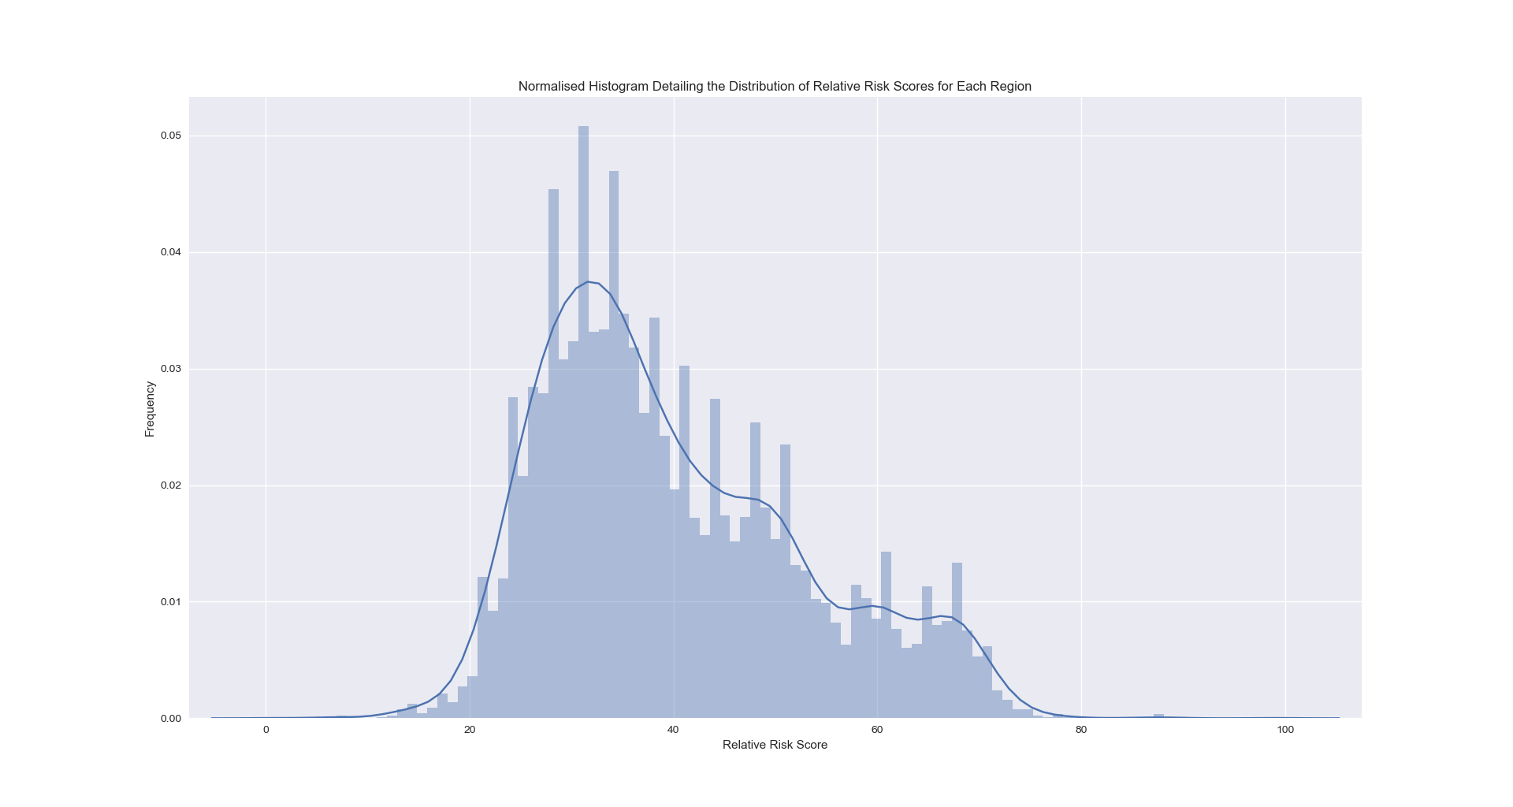

**Figure 2**: Normalised histogram detailing the distribution of relative risk scores for each region.

## Analysis and Comments

### Method

My method of linear interpolation goes some way to protect the scaling from outliers and seemed more intuitive than uniformly distributing via quantiles; it allowed for the easy combination of fields which possess values orders of magnitude apart; and finally, it allowed the regions of a given field to be easily scaled relative to each other within that field.

### Weightings

It would of course be possible to weight the fields in order to preference one over another, e.g.:

|  |  |  |
| --- | --- | --- |
| **Individual Score** | **Weighting** | **Weighted Total Score** |
| 90 | 15% | 75.25 |
| 85 | 15% |
| 70 | 70% |

but without knowing more about the “business understanding” I’m not sure if this would create a better model or simply reinforce my own confirmation bias. I therefore assumed all weights were equal in the process of generating the final risk score.

# About the Author

Hello, World! If you wish to contact me, please select from the following options:

## E-Mail Address and Personal Website

E-Mail: [Matthew.William.Noble@gmail.com](mailto:Matthew.William.Noble@gmail.com)

Personal website: <http://matthewnoble.info/index.html>

## CV and Coding Portfolio

CV (pdf): <https://drive.google.com/open?id=1d6mdd39LRKL2DLfNmaY6xiOlIBJm5653>

CV (online): <http://matthewnoble.info/MyCV.html>

GitHub: <https://github.com/MatthewWilliamNoble/CodingPortfolio>

## Social Media

Facebook: <https://www.facebook.com/matthew.w.noble>

LinkedIn: <https://www.linkedin.com/in/matthew-w-noble/>

Twitter: <https://twitter.com/Matthew_W_Noble>

Instagram: <https://www.instagram.com/matthew.w.noble/>

Kaggle: <https://www.hackerearth.com/@matthew104>

HackerEarth: <https://www.hackerearth.com/@matthew104>

HackerRank: <https://www.hackerrank.com/matthew_noble_11>



1. You can assume your audience understands canonical modelling techniques — please do not present a detailed explanation of a method.
2. See file “Sample_Submission.csv”.